1.

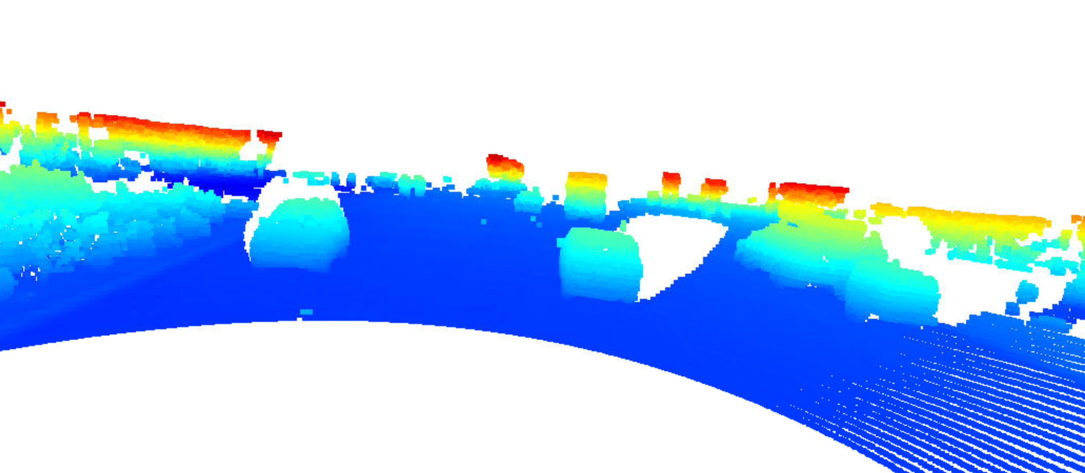

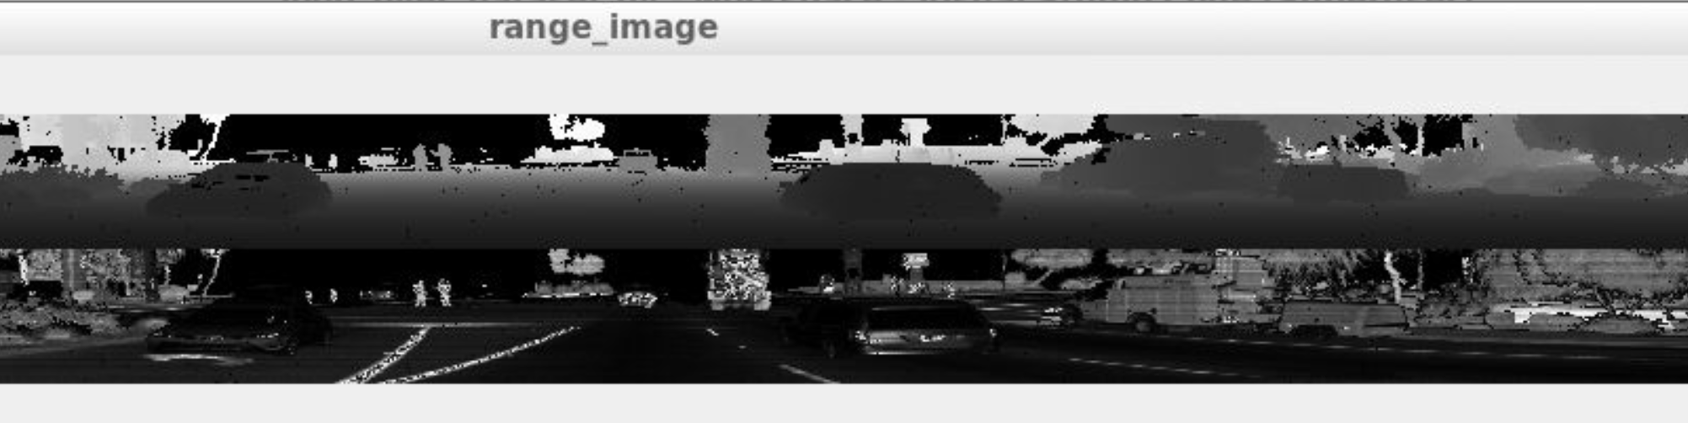

2.

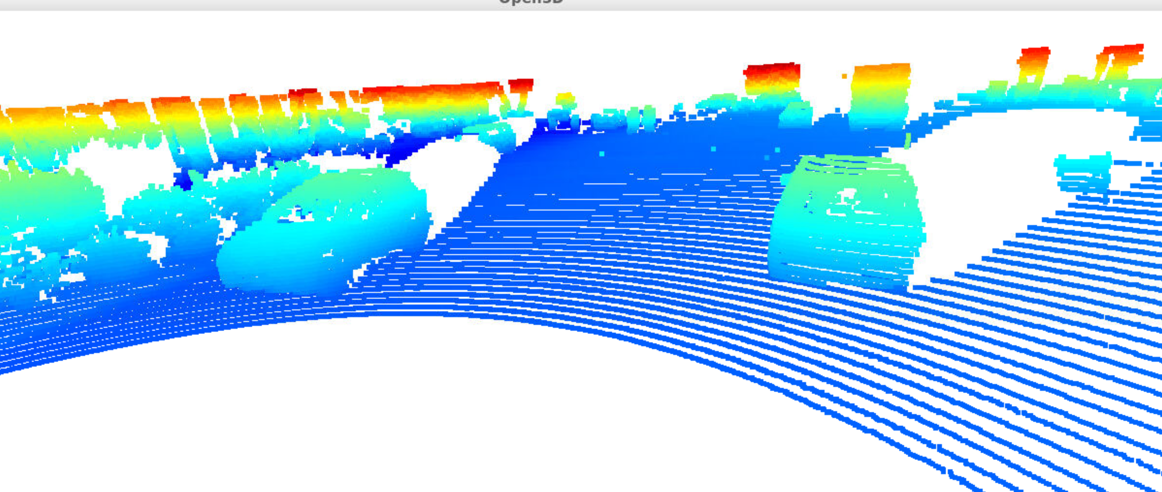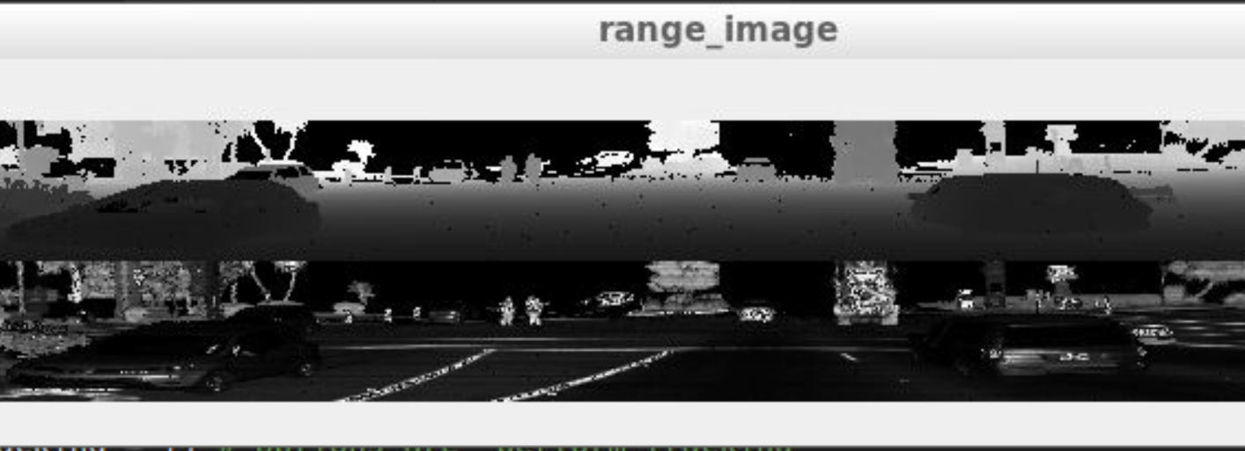

3.

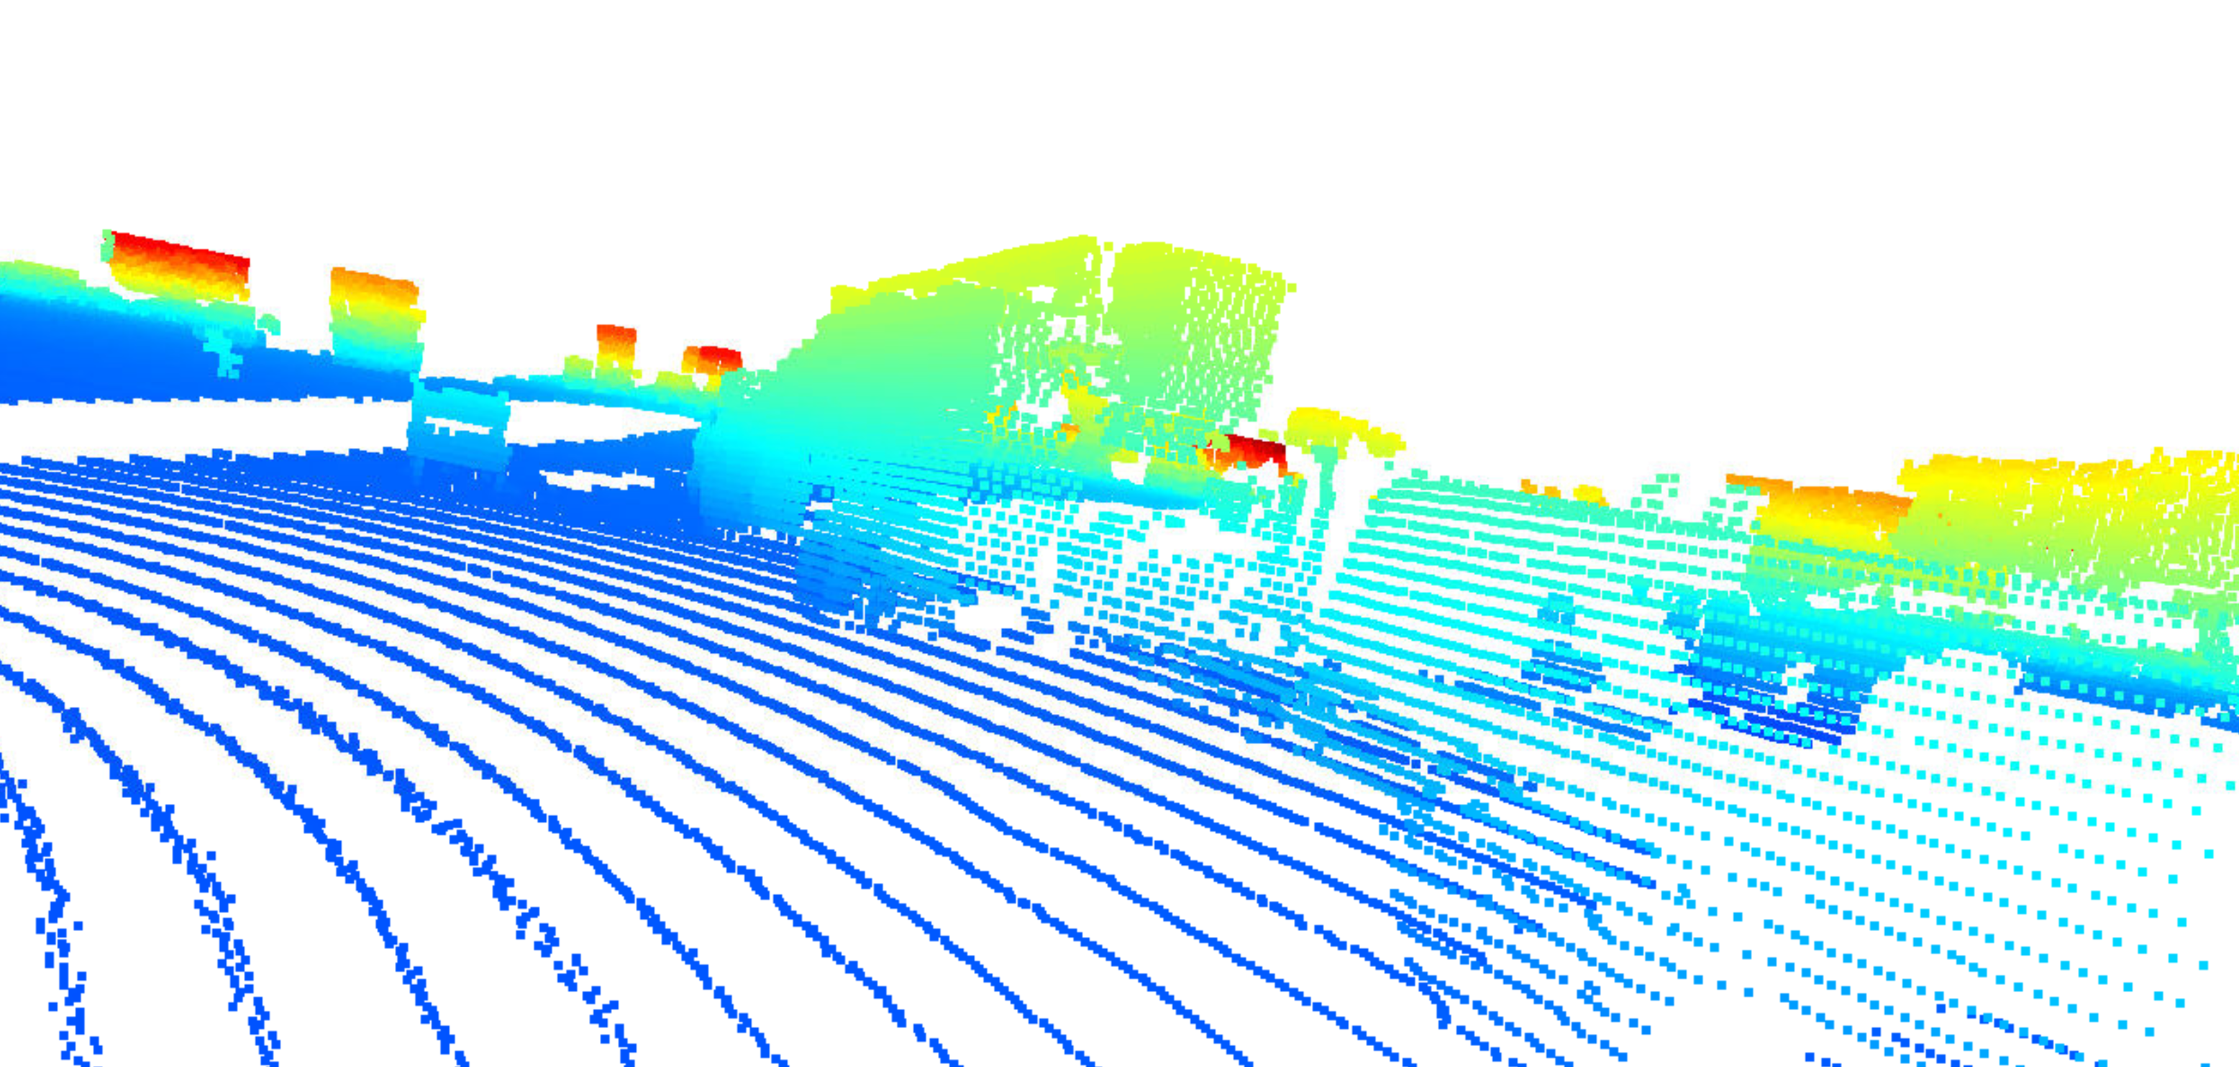

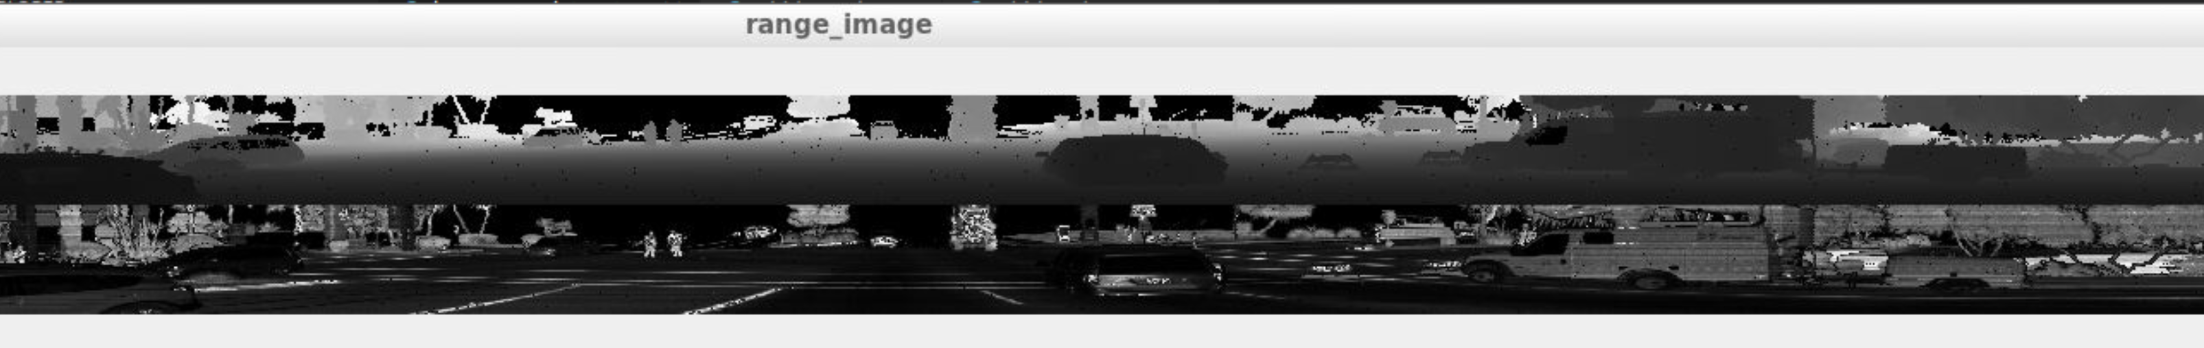

4.

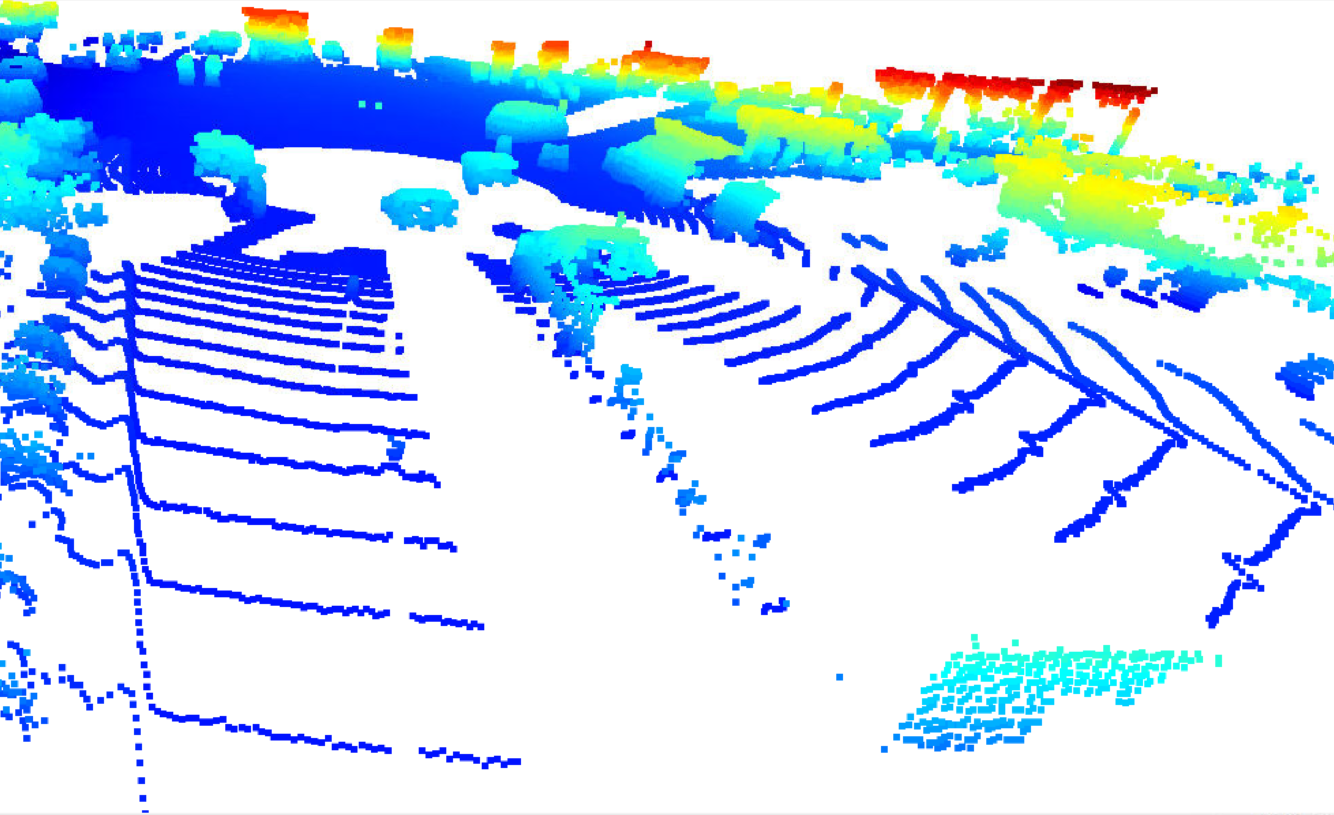

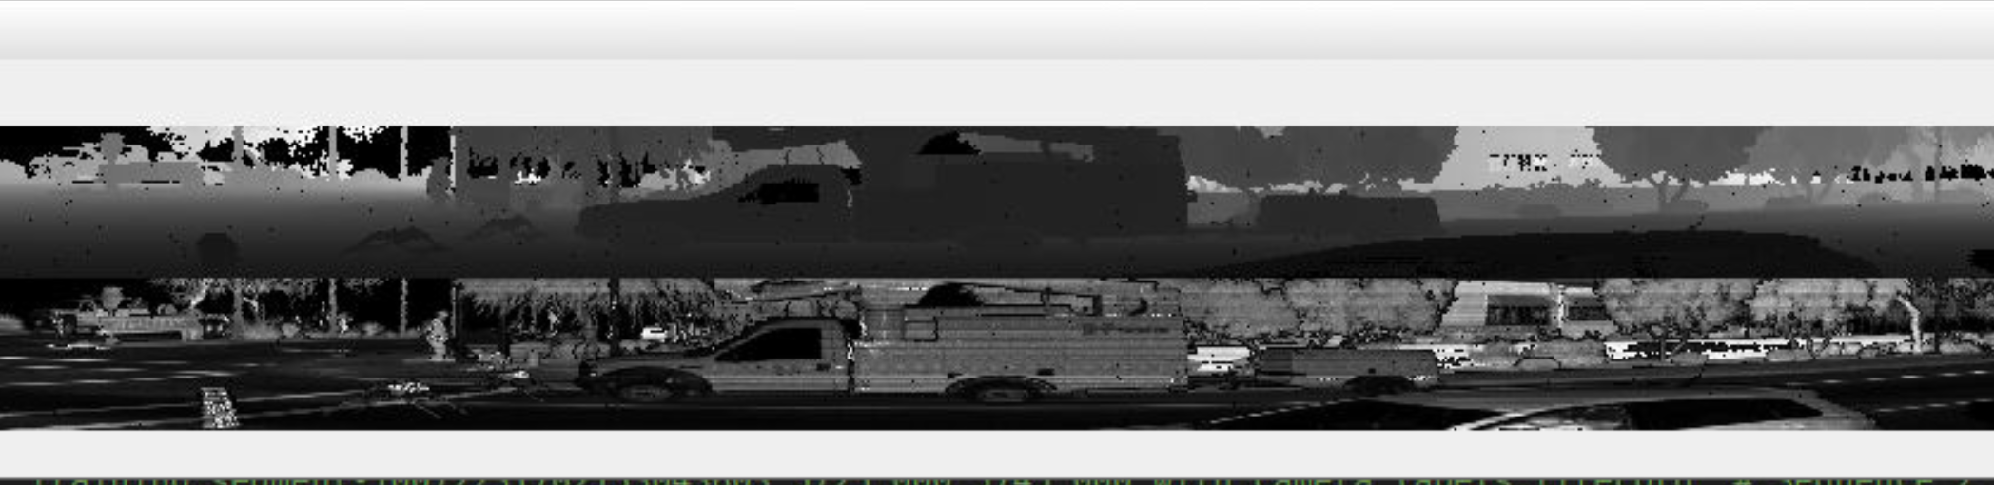

5.

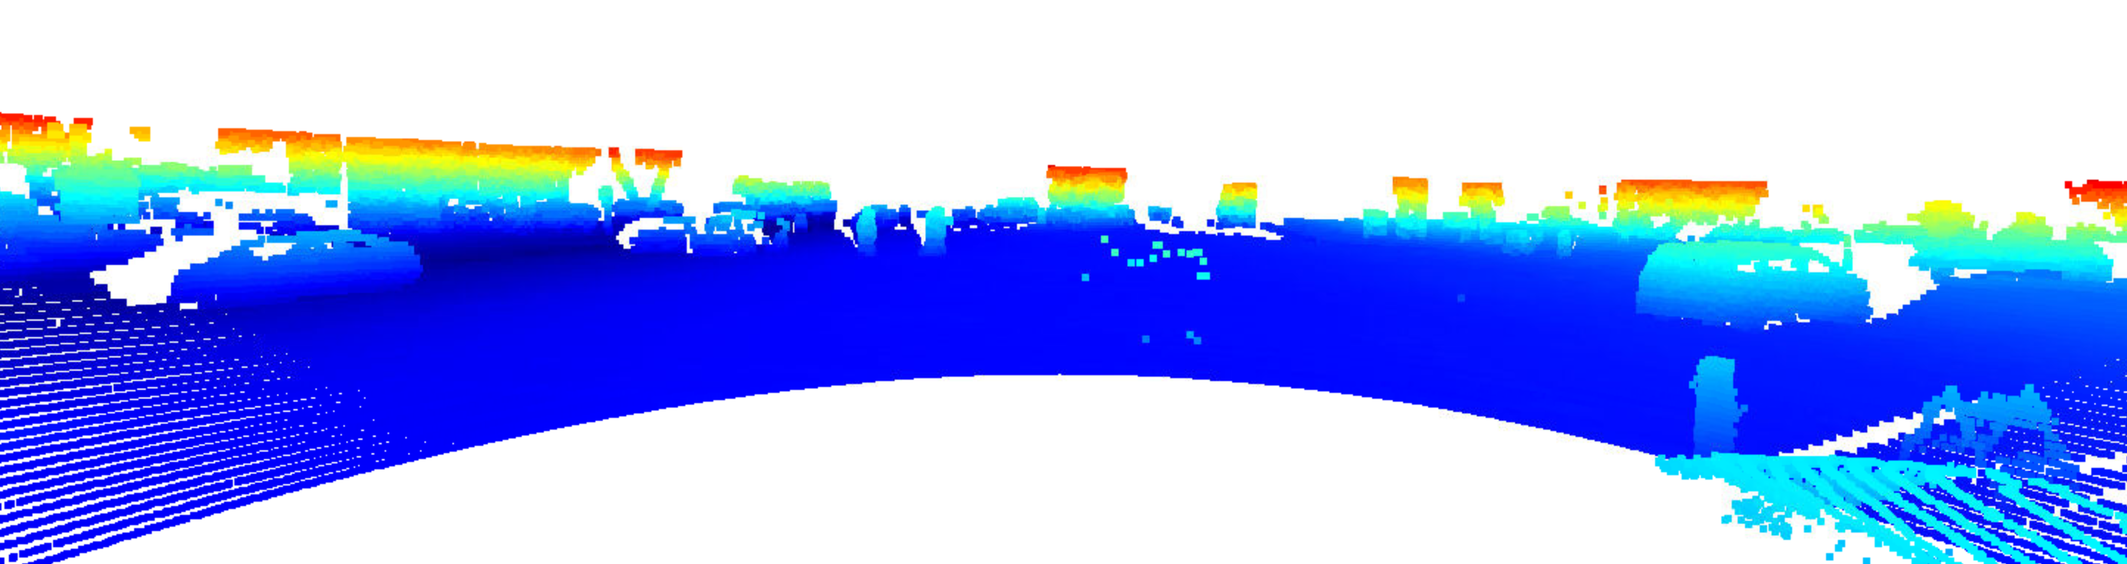

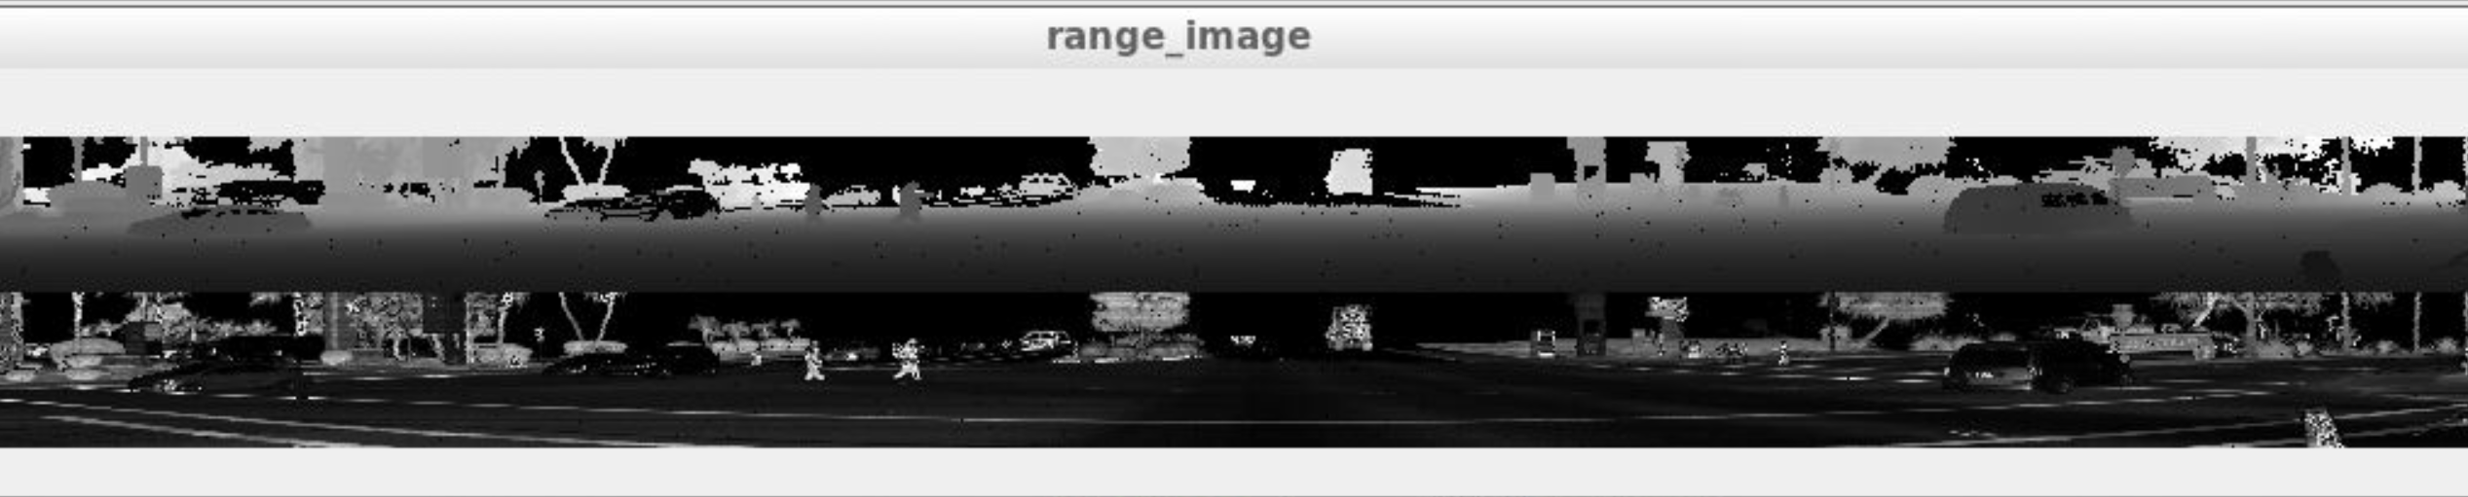

6.

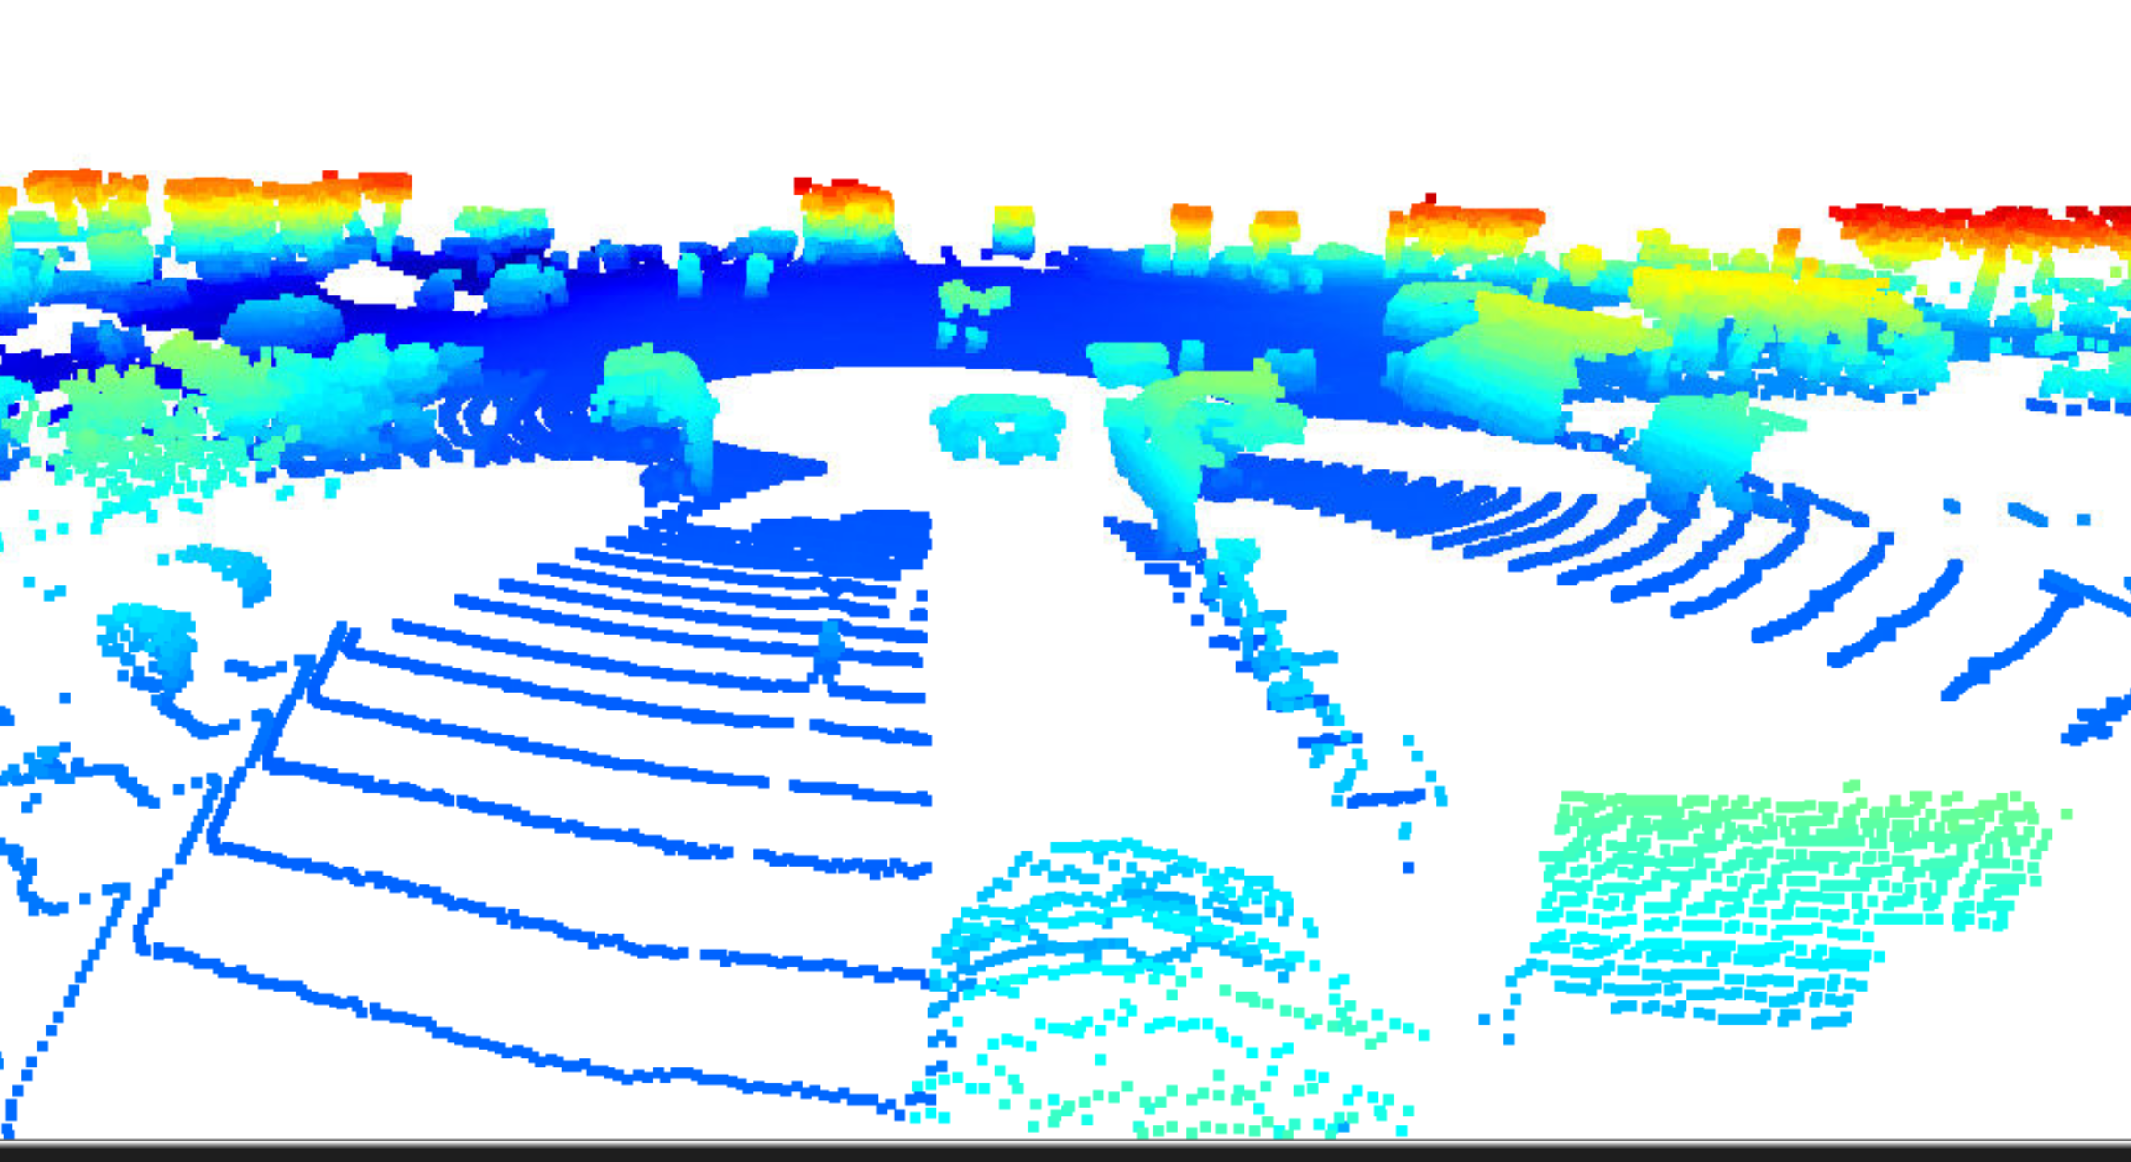

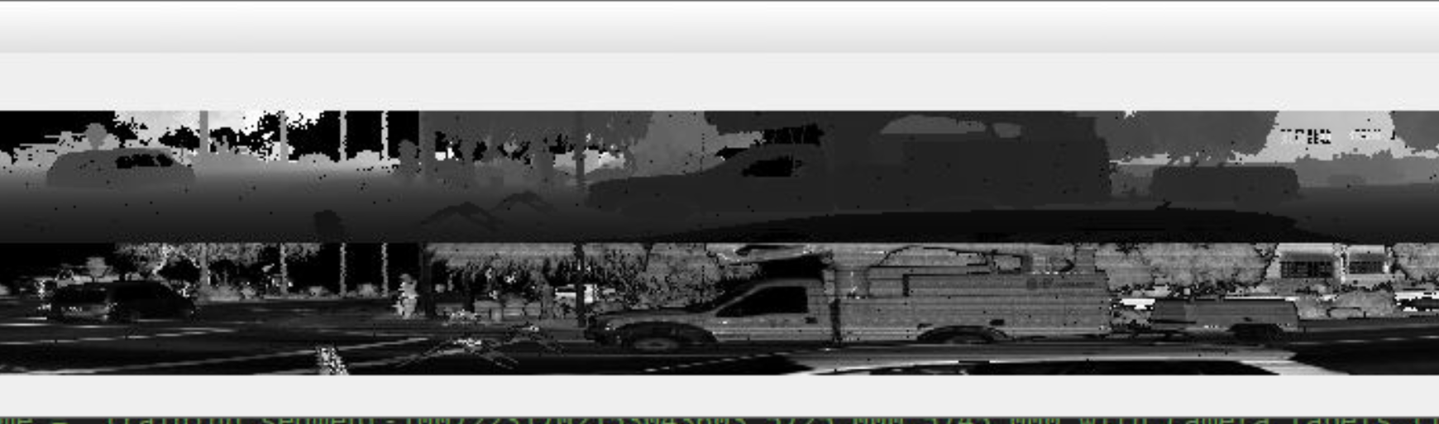

7.

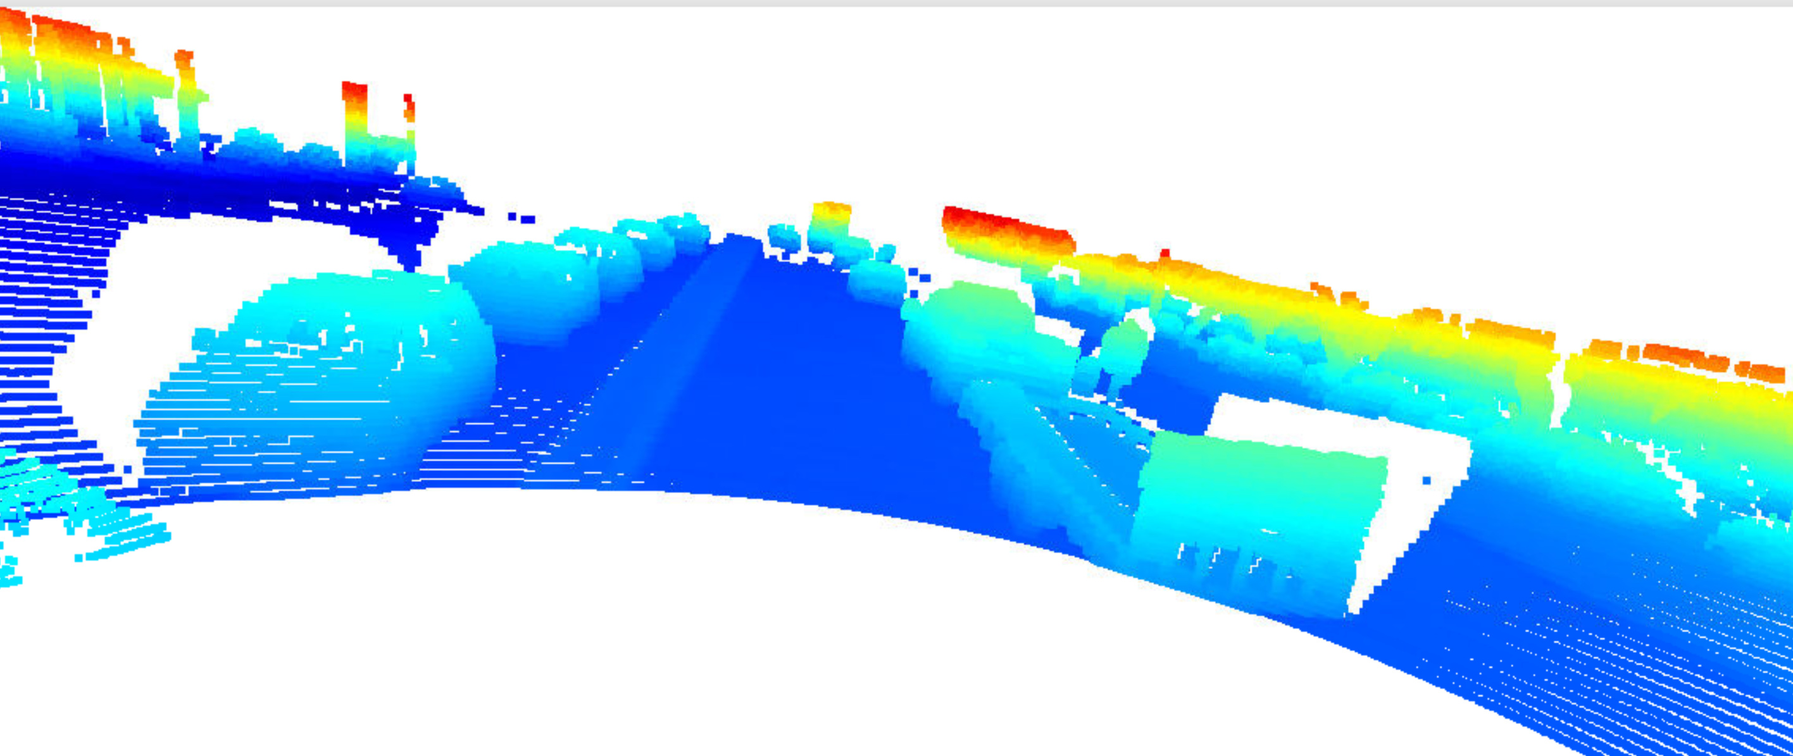

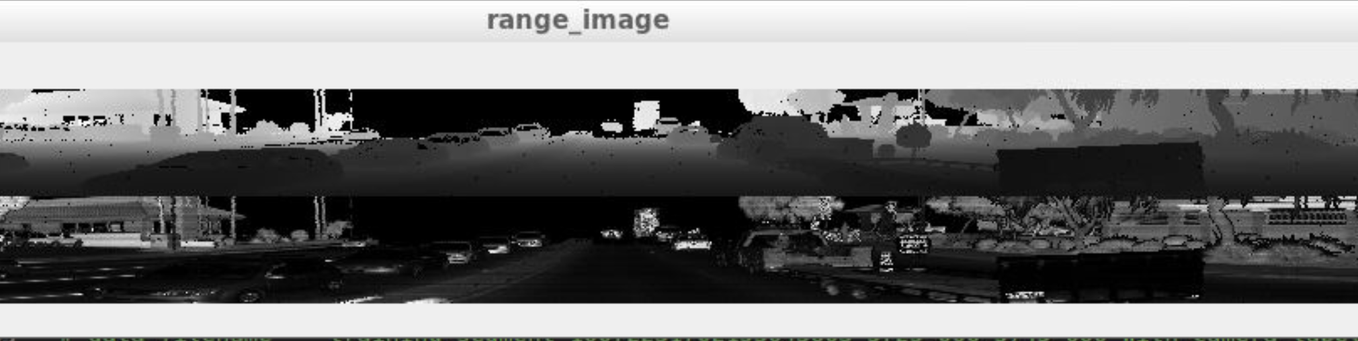

8.

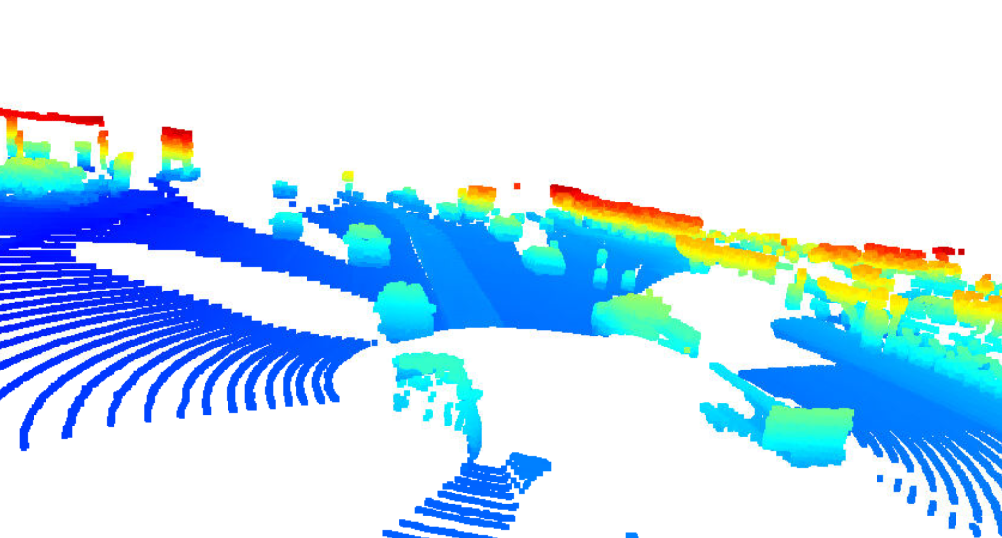

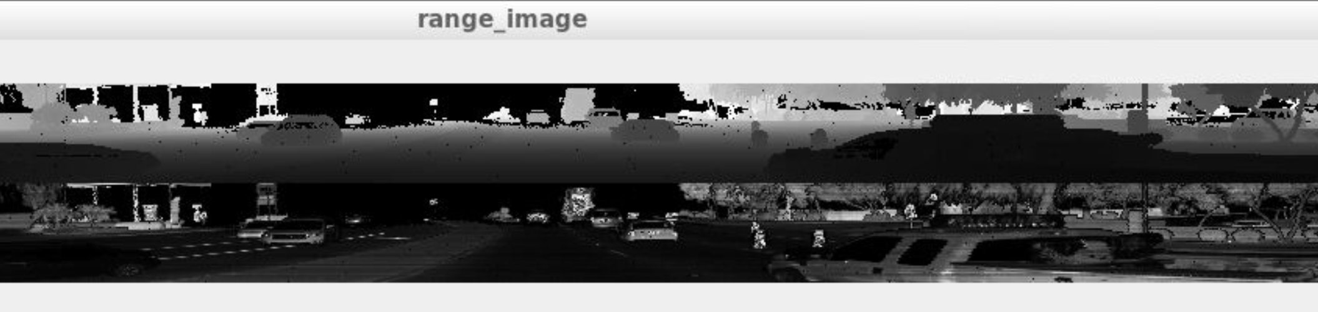

9.

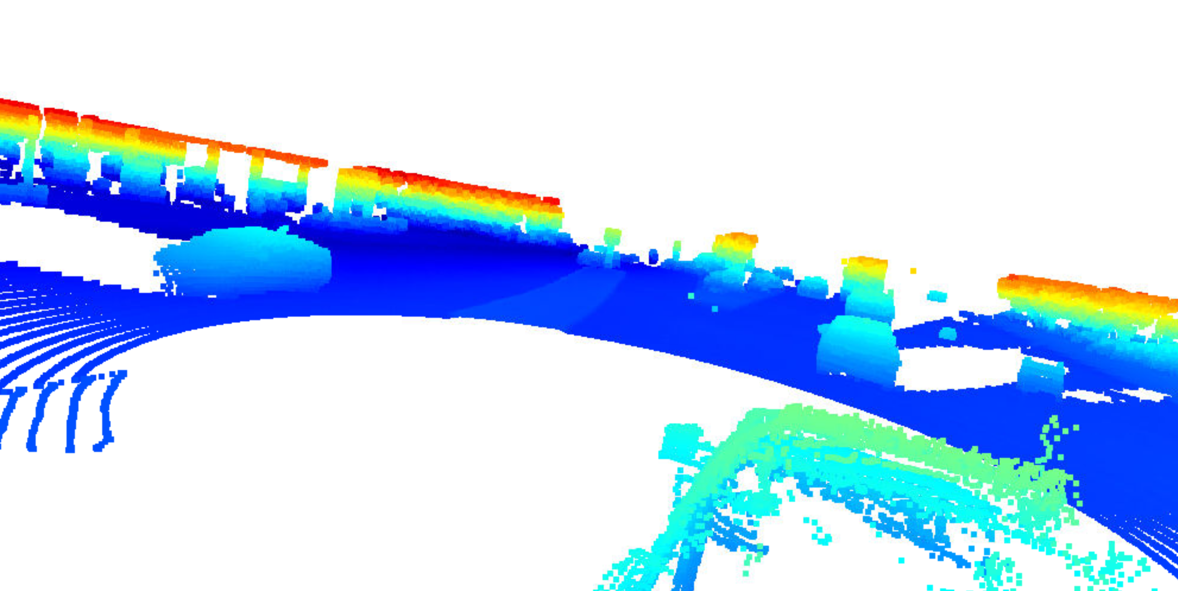

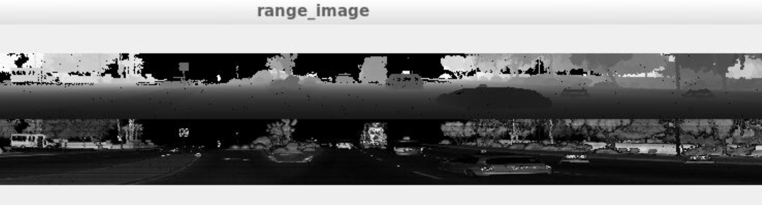

10.

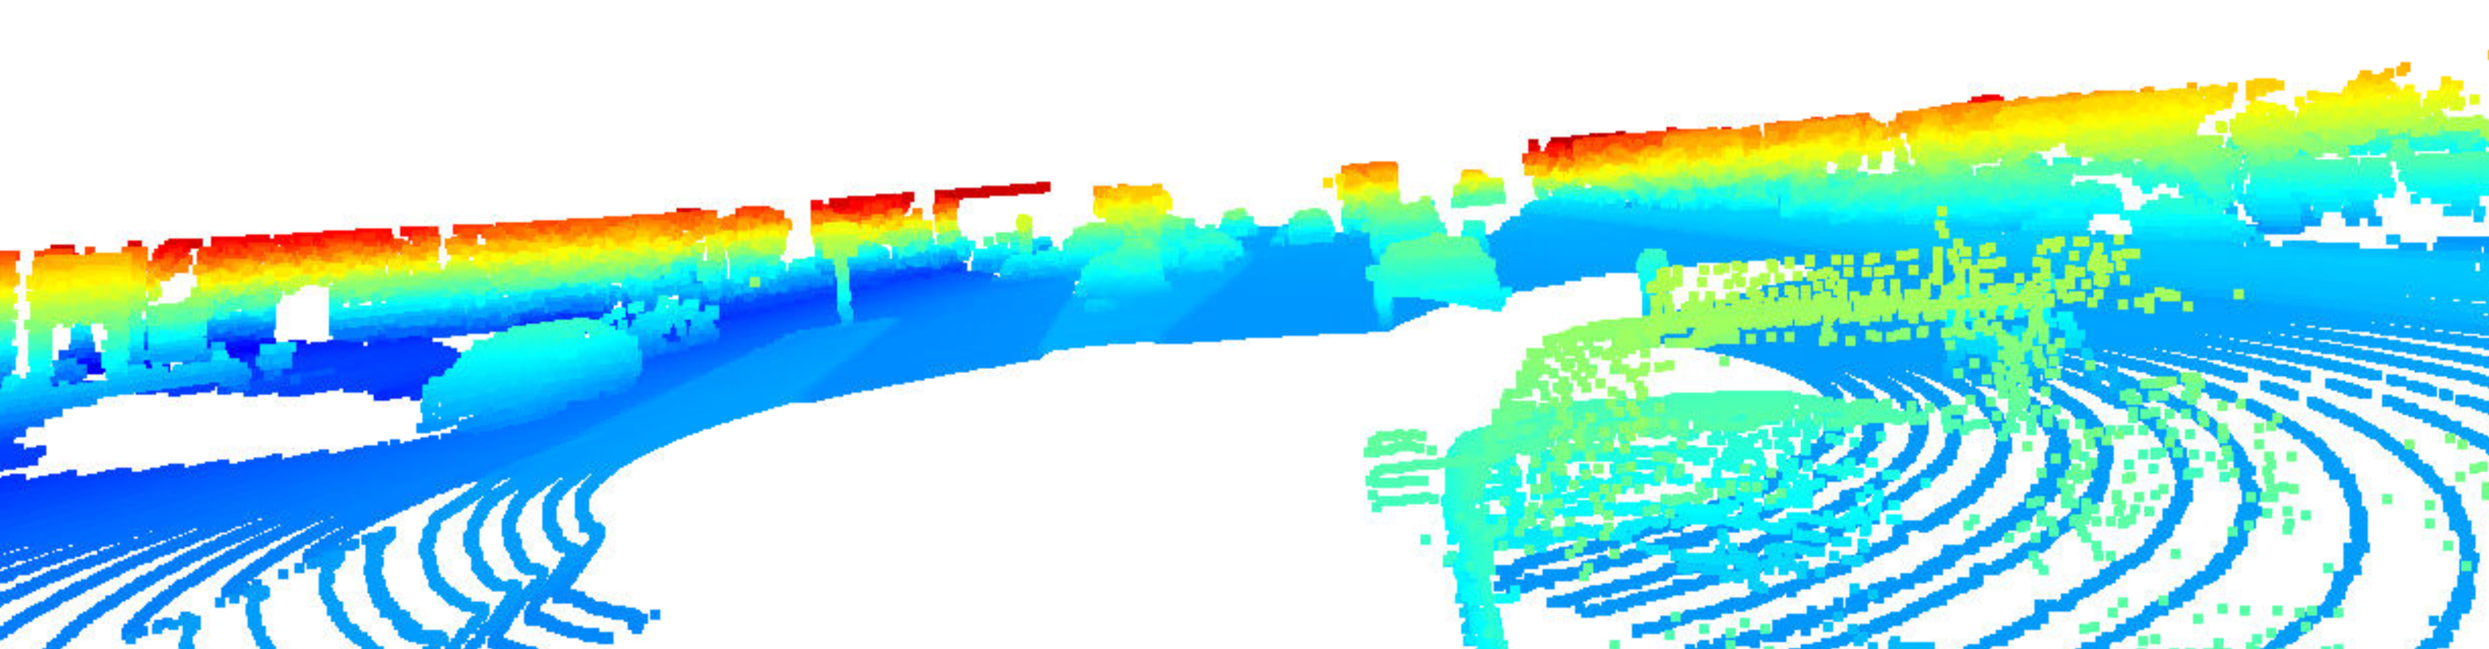

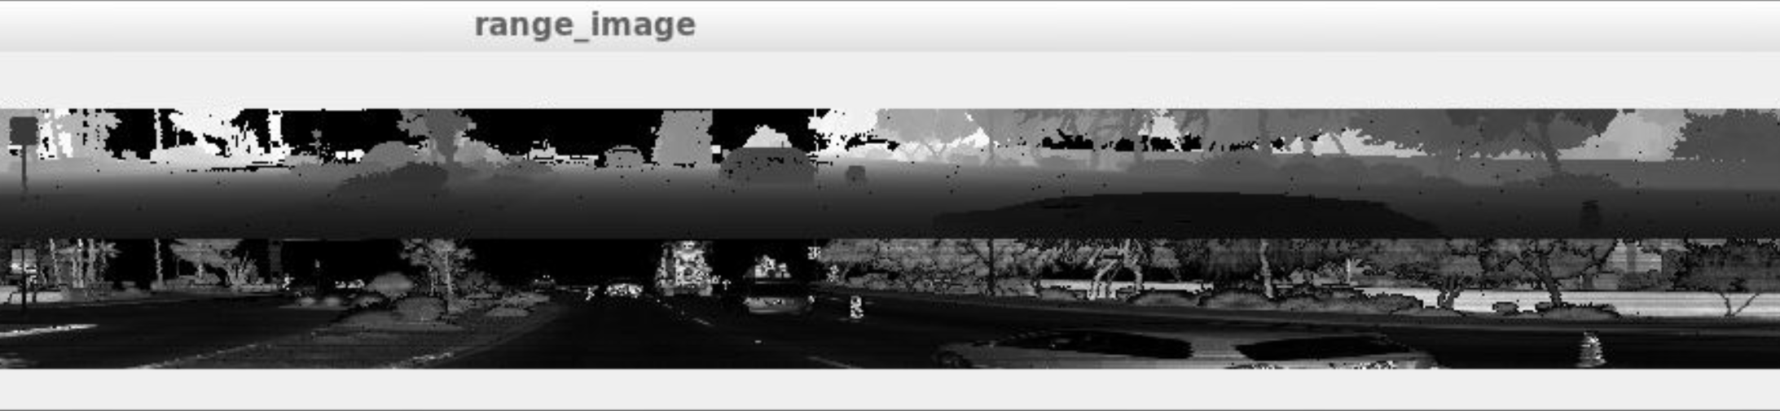

The features that most stuck out and seemed stable were the side-view mirrors and the back part of the lorry (e.g., 6, 7,8). It may have something to do with their sharp edge or higher contrast against the background that is being picked up more clearly. The accompanying intensity images also capture those general frames by showing values closer to white.

***‘Create Birds-Eye View from Lidar PCL’***

During the "Create Birds-Eye View from Lidar PCL" part of the project, I obtained the expected plots, as shown below:

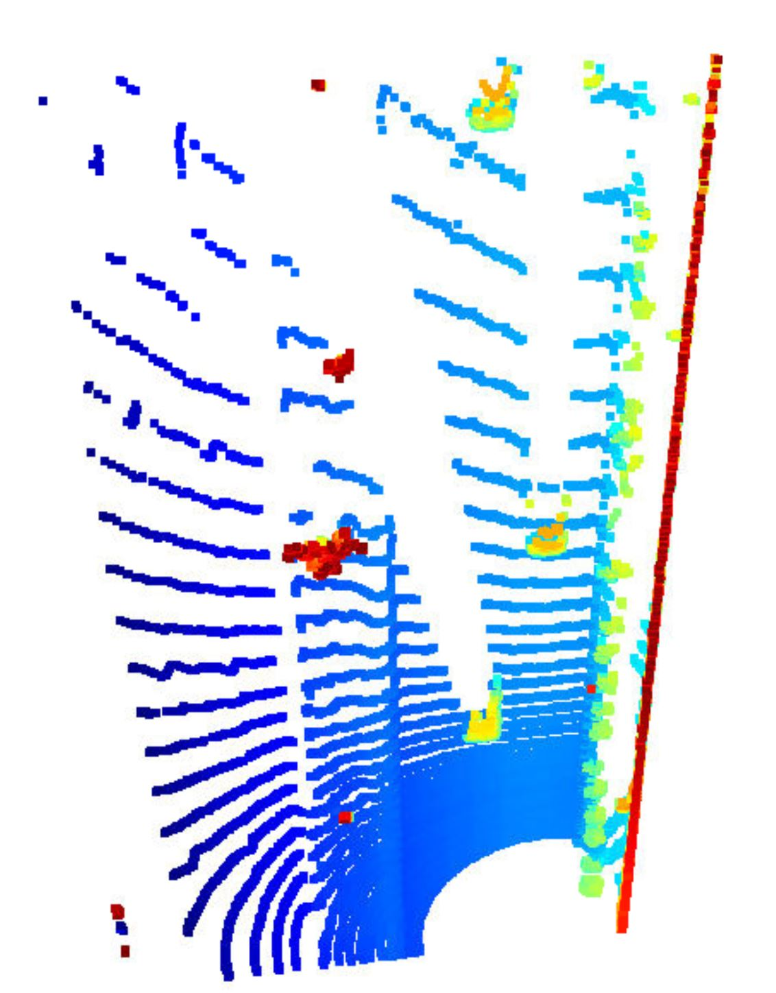

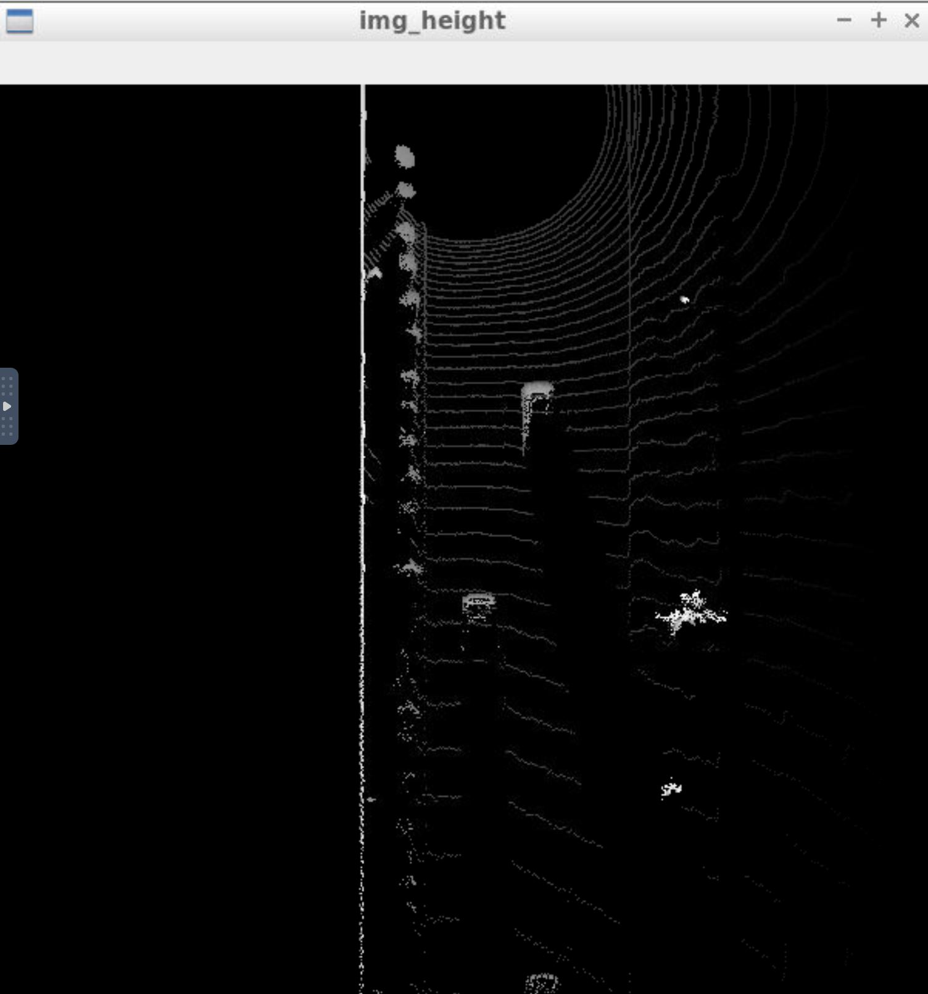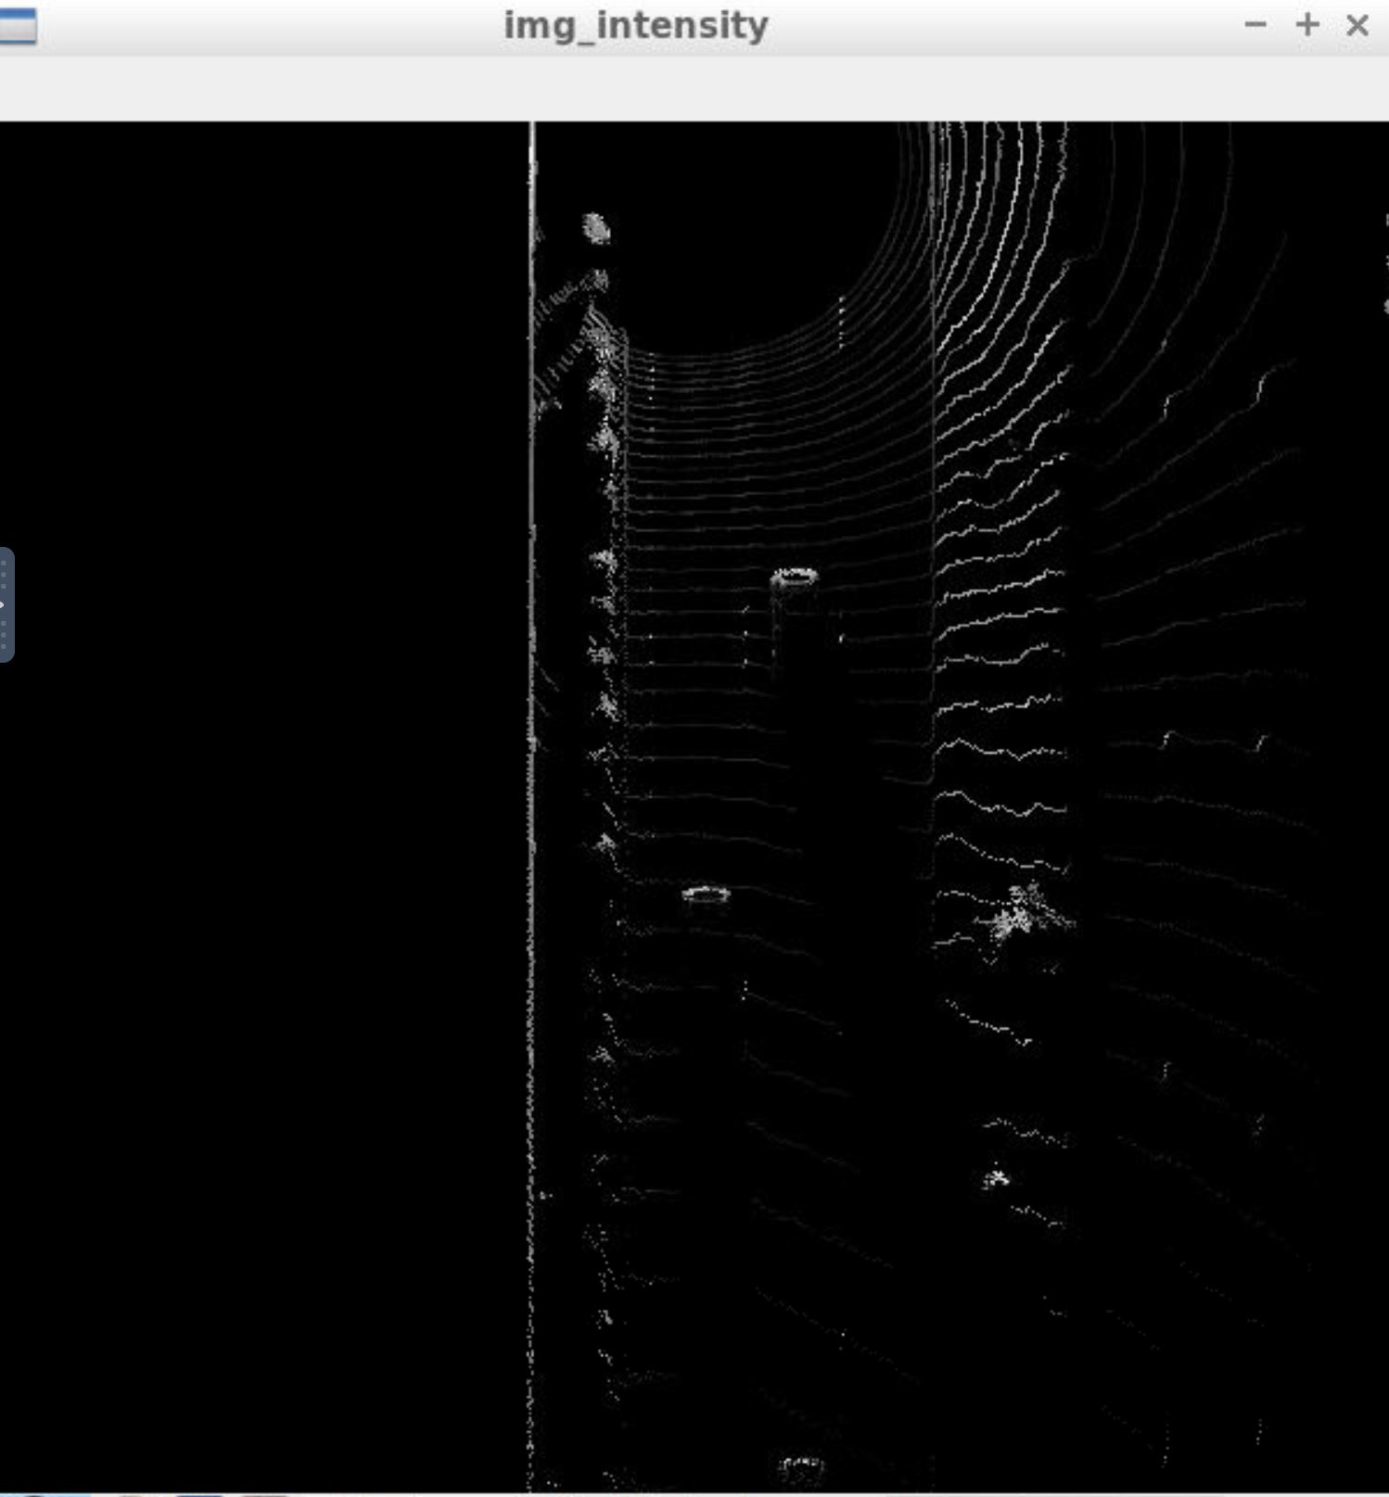

***‘Model-based Object Detection in BEV Image’***

When performing the "Model-based Object Detection in BEV Image" part, the following detections were received for frame 51. Frame 50 did not have the one at the top.

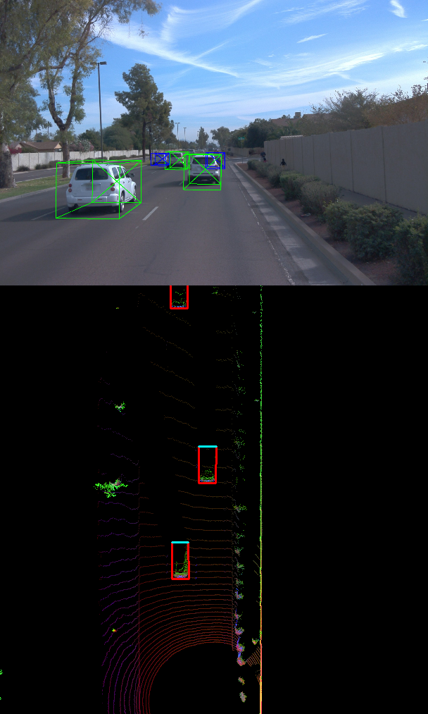

***Performance Evaluation for Object Detection***

The following plots were obtained during the performance evaluation stage:

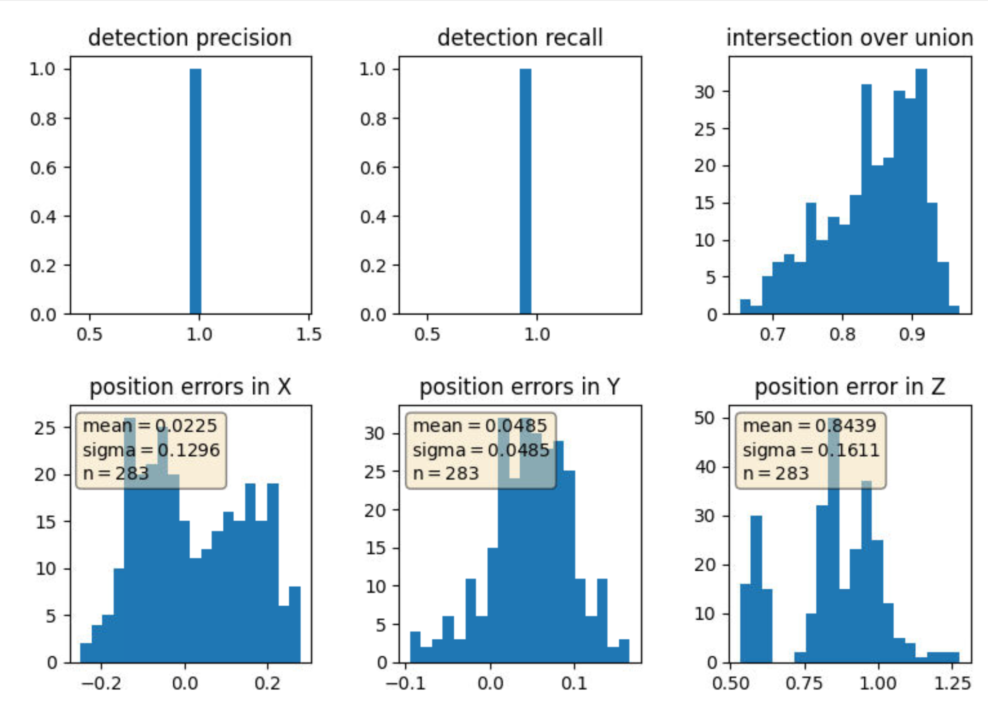

precision = 0.9593220338983051, recall = 0.9248366013071896

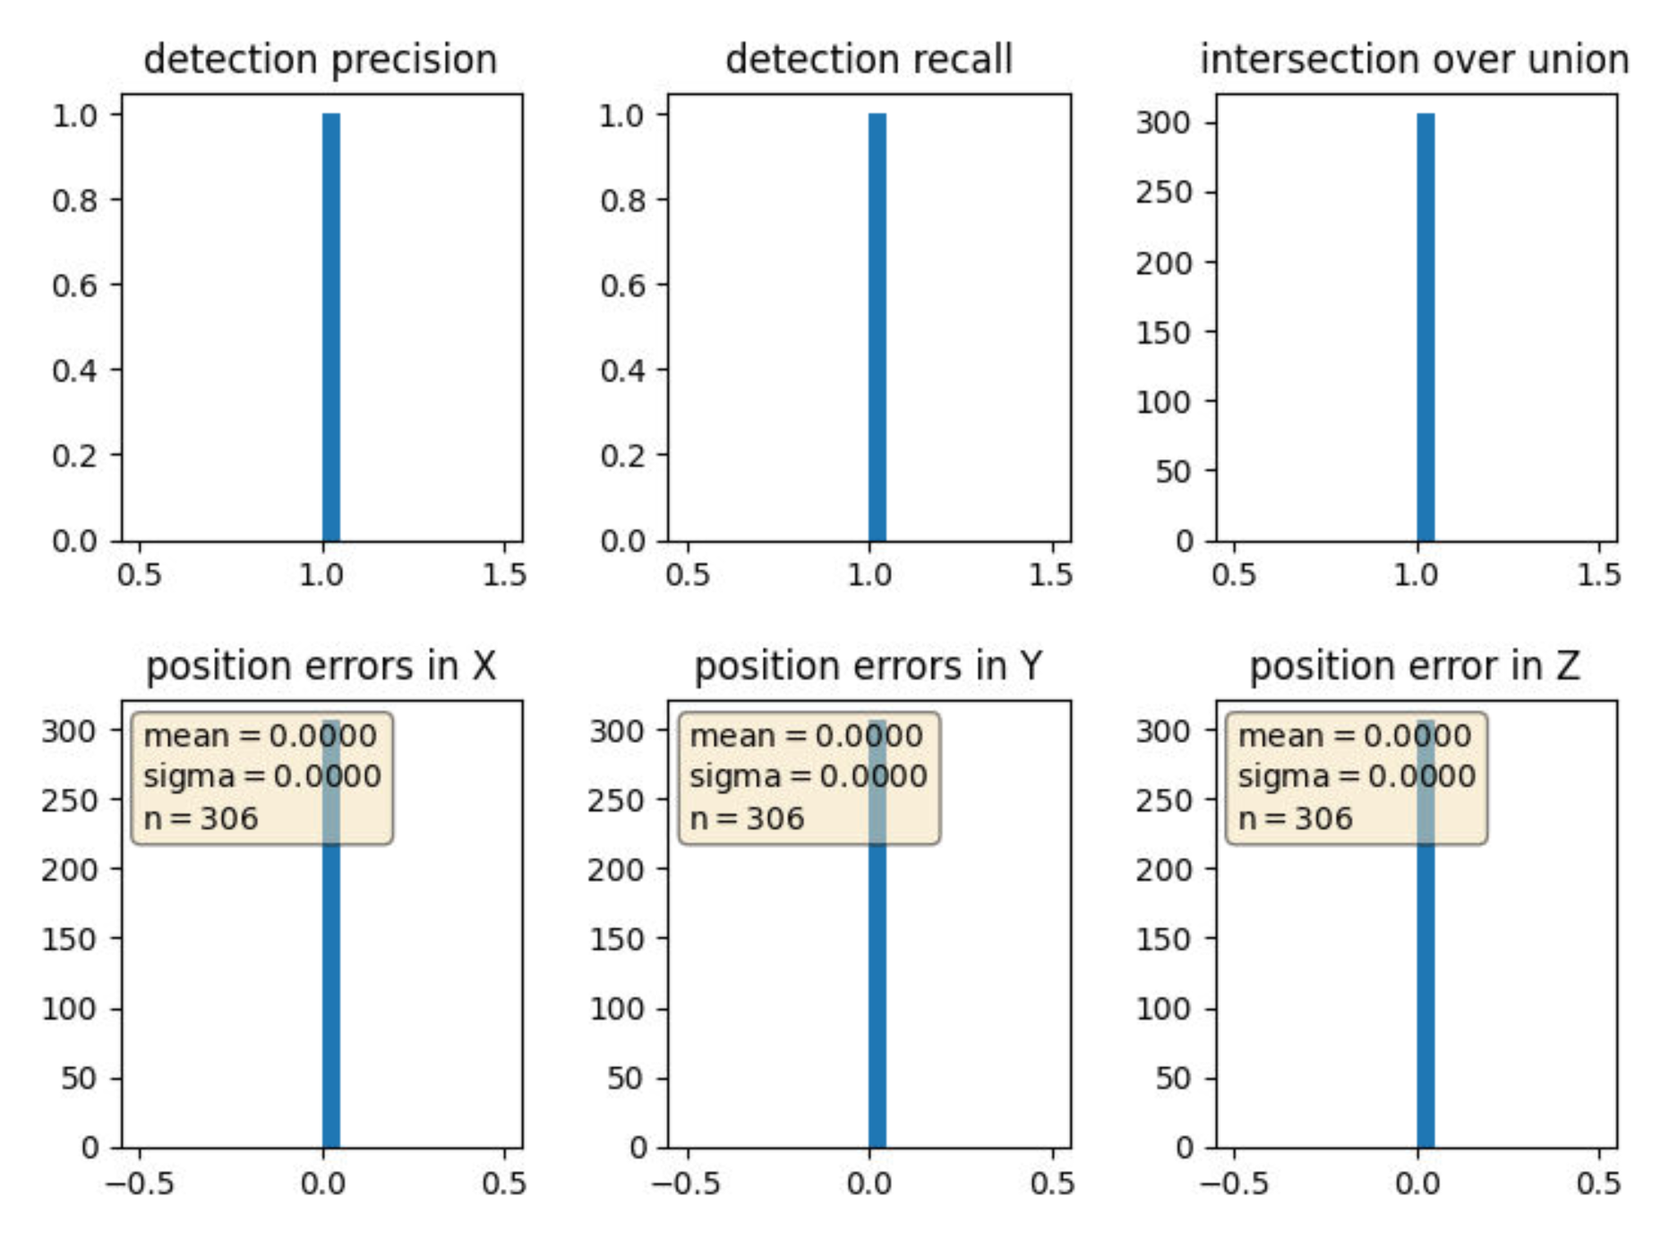

precision = 1.0, recall = 1.0